PT Activity 1: Install Broadband Services

Topology Diagram

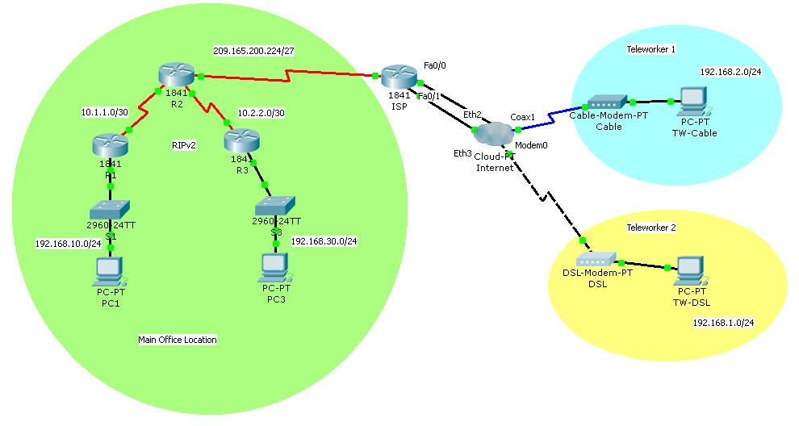

Learning Objectives
- Connect the ISP to the Internet cloud.
- Add WAN devices.
- Connect a WAN device to the Internet cloud.
- Connect teleworker PCs to WAN devices.
- Test connectivity.
Introduction
In this activity, you will demonstrate your ability to add broadband devices and connections to Packet Tracer. Although you cannot configure DSL and cable modems, you can simulate end-to-end connectivity to teleworker devices.
Task 1: Connect the ISP to the Internet Cloud
Step 1. Make connections using the interfaces shown in the topology.
- Connect Fa0/0 on ISP to Eth2 on the Internet Cloud.
- Connect Fa0/1 on ISP to Eth3 on the Internet Cloud.
Step 2. Check results.
Your completion percentage should be 25%. If not, click Check Results to see which required components are not yet completed.
Task 2: Add WAN Devices
Step 1. Add DSL and cable devices.
The DSL Modem and Cable Modem devices are under the WAN Emulation menu. Place them as you would any other device.
Step 2. Name the WAN devices.
Use the Config tab to change the display name of each WAN device to Cable and DSL, respectively.
Task 3: Connect WAN Devices to the Internet Cloud
Step 1. Connect the cable modem to the Internet cloud.
Choose the Coaxial connection type from the Connection menu.
Step 2. Connect the DSL modem to the Internet cloud.
Choose the Phone connection type from the Connection menu.
Step 3. Check results
Your completion percentage should be 75%. If not, click Check Results to see which required components are not yet completed.
Task 4: Connect Teleworker PCs to WAN Devices
Step 1. Connect TW-Cable to Cable.
Step 2. Connect TW-DSL to DSL.
Step 3. Check results.
Your completion percentage should be 100%. If not, click Check Results to see which required components are not yet completed.
Task 5: Test Connectivity
Click Check Results, and then click the Connectivity Tests tab to verify that the Teleworker devices can communicate with the internal PCs.

